https://colorizer.org/

<https://www.khanacademy.org/computing/pixar/color/color-101/e/hsl-color-matching>

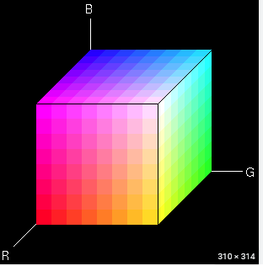

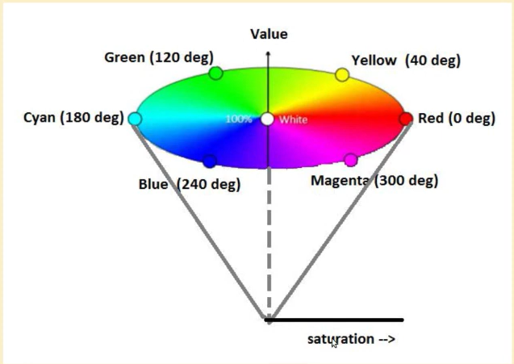

**HSV**

**HSV -> H=320 , S = 0.857 , V = 0.7**

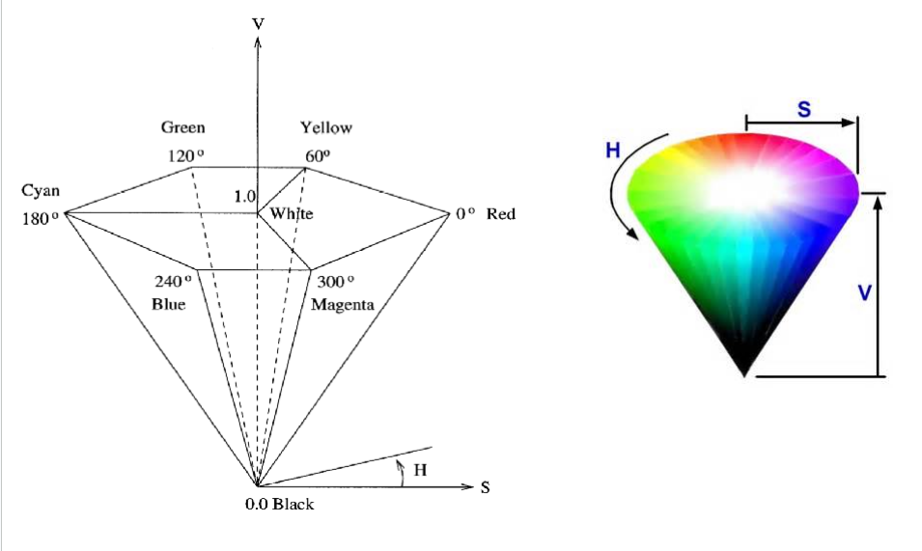

**HSV**

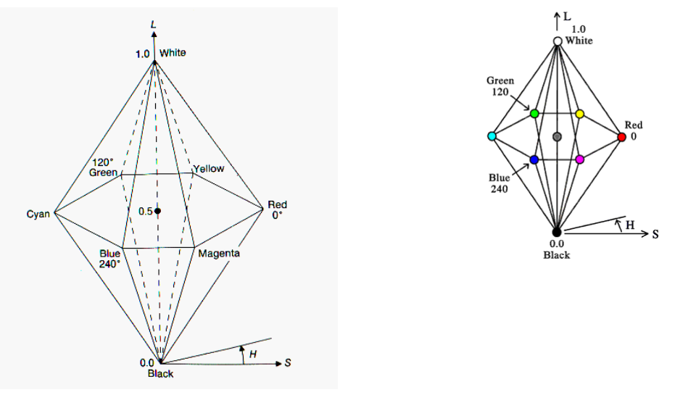

**HSL**

**HSL -> H = 320 , S = 0.75 , L = 0.4**

**RGB/CMY color model → HSV / HSL color model**

RGB (0.2,0.4,0.8) → HSL

Conversion Algorithm :

Step-1 : max = MAX (R,G,B)

min = MIN (R,G,B)

l = max-min

Step-2 :

**(HSL)** → L = (max+min)/2

S= l / (1- | 2L-1 | )

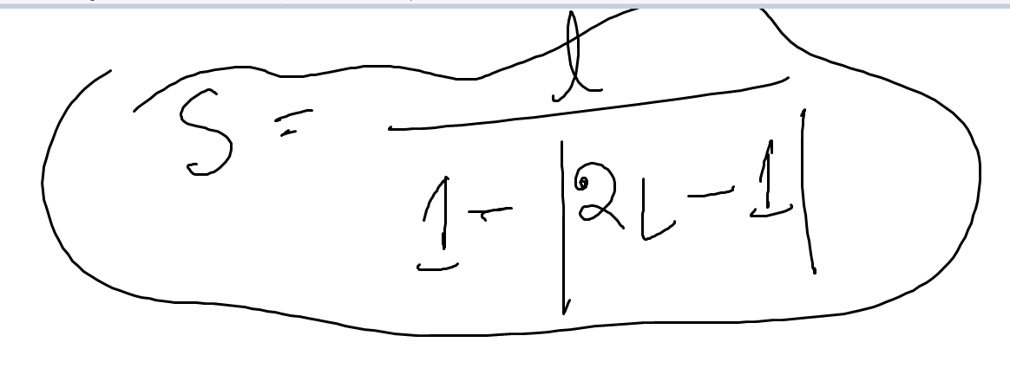

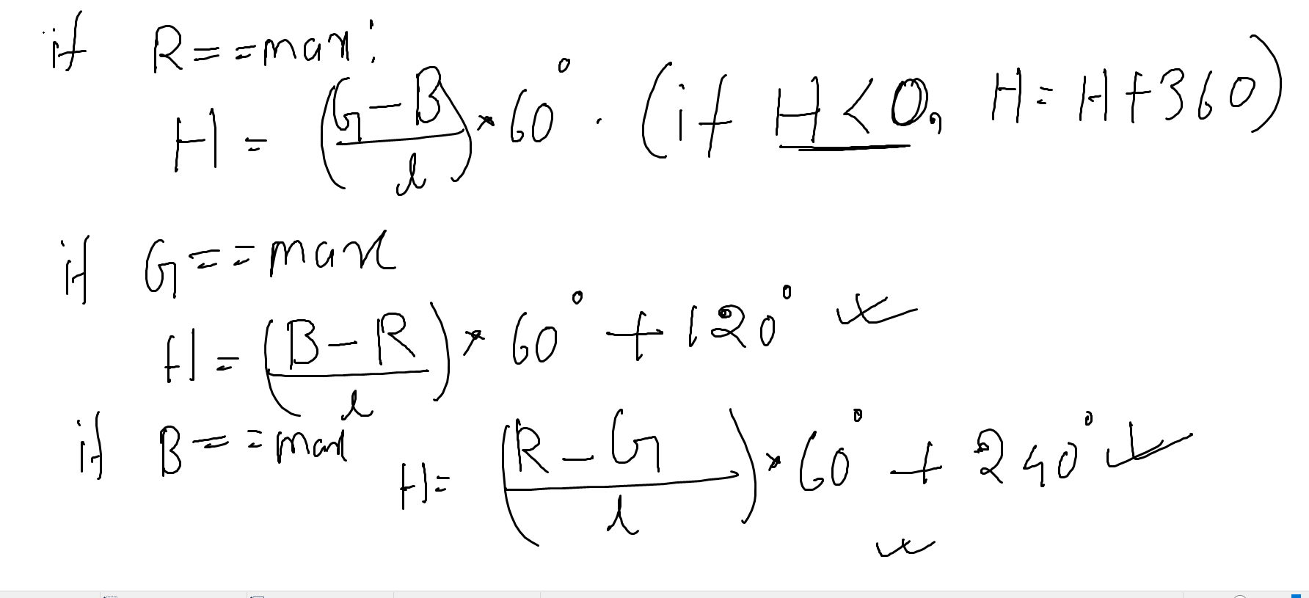

**HSV :**

V = max

S = 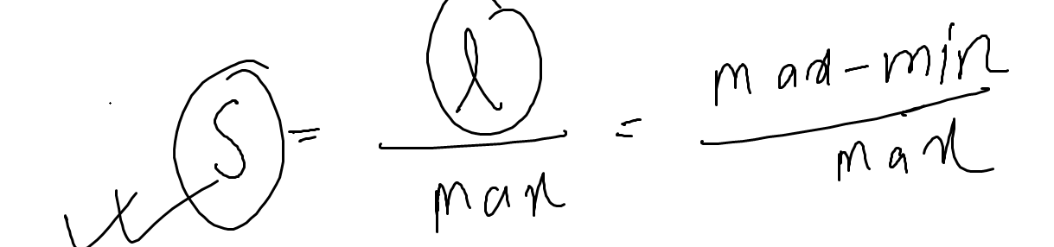



Math →

RGB (0.7, 0.25, 0.3) → HSV / HSL

R = 0.7 , G = 0.25, B = 0.3

Max = 0.7

Min = 0.25

l = max-min = 0.7-0.25 = 0.45

HSV :

V = max = 0.7

S= 0.45 / 0.7 = 0.64

H = ( (G-B)/ l ) * 60

= ((0.25-0.3) / 0.45 ) * 60

= -6.67

H = -6.67 + 360 = 353.33

HSL →

L = (0.7 + 0.25)/2 = 0.475

S= 0.45 / (1- | 2*0.475 - 1 | ) = 0.474

H = -6.67 + 360 = 353.33

CMY (0.7,0.3,0.2) → HSV / HSL

CMY → **RGB (0.3 , 0.7, 0.8)**

Max = 0.8, min =0.3, l = 0.8-0.3 = 0.5

HSV →

V = max = 0.8

S= l / max = 0.5 / 0.8 = 0.625

H = ((**0.3-0.7) /** 0.5 ) * 60 + 240 = 192

HSL → L = 0.55 , S = 0.56, H=192



      
          
          
        
        





      
          
          
        
        